Milestone 2 Submission

**September** 2020

***Team: 3.THURS-10:30-5***

# Team Members

Marcus Matic s3703981 *Back End Coder*

***Contribution percentage*** : 20% ***List of contributed items*** :

* User cards 4, 5, 6
* Acceptance tests 4.1, 4.2, 5.1, 5.2, 6.1
* Schema/Model Management
* JUnit tests
* Repos for Appointments, Availability, Bookings, Workers

Raymond Caucci s3779722 *Front End Coder*

***Contribution percentage*** : 20%

***List of contributed items*** :

* User cards 10, 11, 12
* Acceptance tests 10.1, 10.2, 11.1, 11.2, 12.1, 12.2
* Signup and login form.
* Form validation.
* About us page.
* Home page
* Contact us Page.
* Unit Tests.
* Dashboard

Michael Weston s3541742 *Back End Coder*

***Contribution percentage*** : 20% ***List of contributed items*** :

* User cards 7, 8, 9
* Acceptance tests 7.1, 7.2, 8.1, 9.1, 9.2
* Spring-boot/coding tutorials
* Unit tests
* CircleCI
* Repo maintenance
* Handling data requests to Back-End for workers and businesses

Marco Nadalin s3782230 *Product Owner, Front End Coder*

***Contribution percentage*** : 20% ***List of contributed items*** :

* User cards: 13, 14, 15
* Acceptance tests: 13.1, 14.1, 14.2, 15.1
* Trello Reformatting and organisation
* Signup and login functionality (sending and receiving data to and from backend)
* Service booking page and functionality
* Dashboard
* Unit Tests

Athanasios Papaharisis s3372134 *Scrum Master*

***Contribution percentage*** : 20% ***List of contributed items*** :

* User cards 1, 2, 3
* Acceptance tests 1.1, 1.2, 1.3, 2.1, 2.2, 3.1, 3.2
* Trello Reformatting and organisation
* Document creation/compilation
* Meeting planner/organiser
* Scrum Master

Communication links

***Github****:* [*https://github.com/orgs/RMIT-SEPT/teams/3-thurs-10-30-5/repositories*](https://github.com/orgs/RMIT-SEPT/teams/3-thurs-10-30-5/repositories)

***Trello****:*

[*https://trello.com/b/TCYa6H6K/sept-project-thurs1030-team-5*](https://trello.com/b/TCYa6H6K/sept-project-thurs1030-team-5)

***Discord (Slack Alternative) :***[*https://discord.gg/t2A4Cdc*](https://discord.gg/t2A4Cdc)

***AWS account :*** [*http://ec2-3-95-192-154.compute-1.amazonaws.com/*](http://ec2-3-95-192-154.compute-1.amazonaws.com/)

***CircleCI :*** [*https://app.circleci.com/pipelines/github/RMIT-SEPT/majorproject-3-thurs-10-30-5*](https://app.circleci.com/pipelines/github/RMIT-SEPT/majorproject-3-thurs-10-30-5)

Communication Log Examples

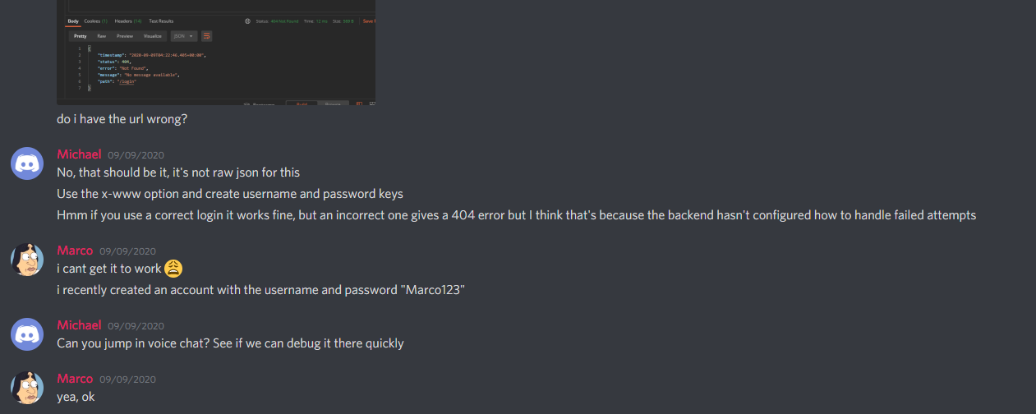

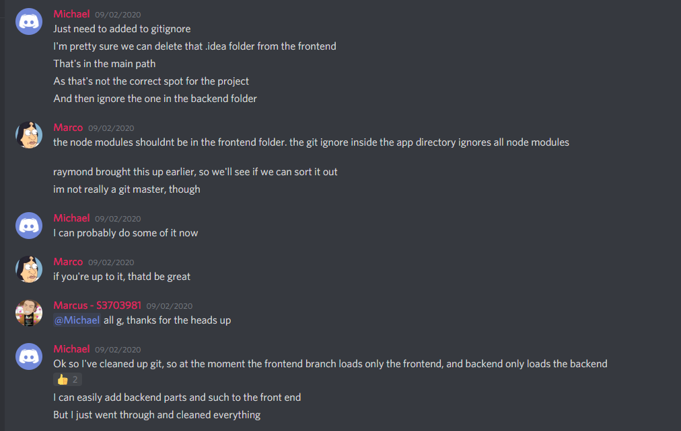

# Test case Documentation

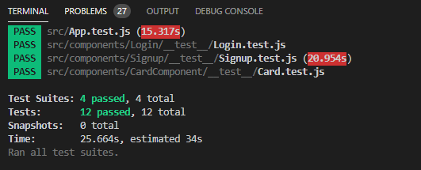

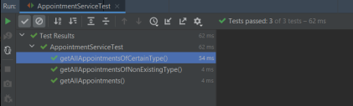

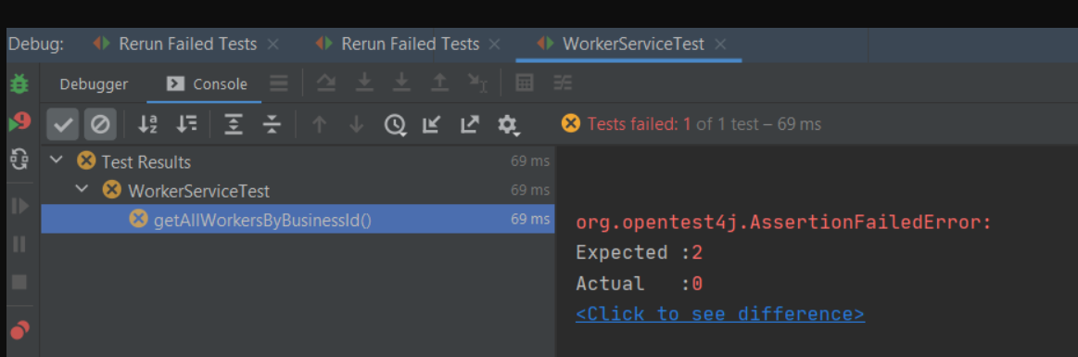

# CircleCI Testing

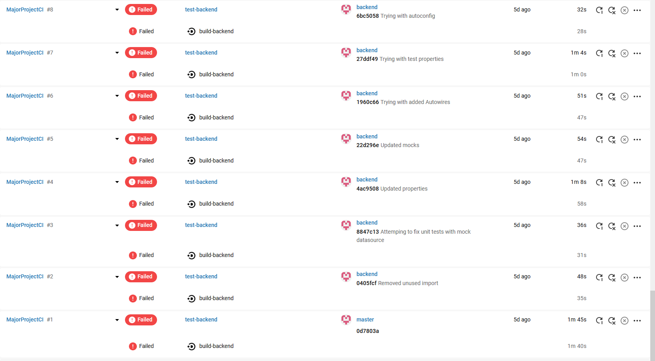

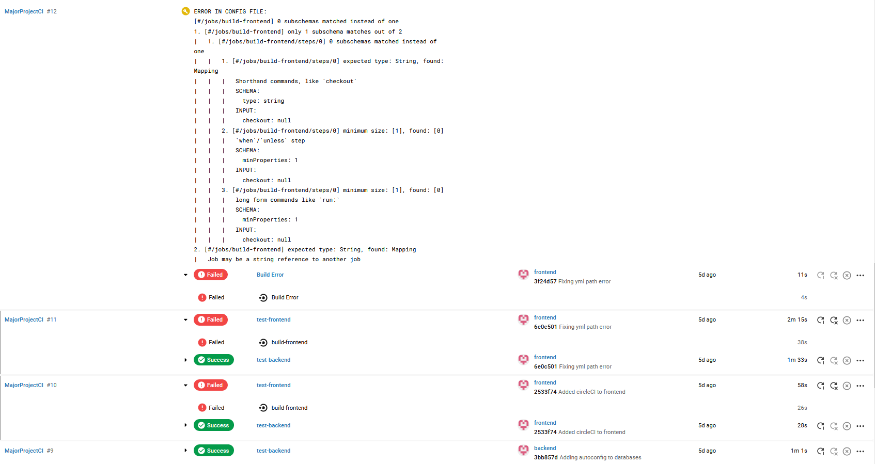

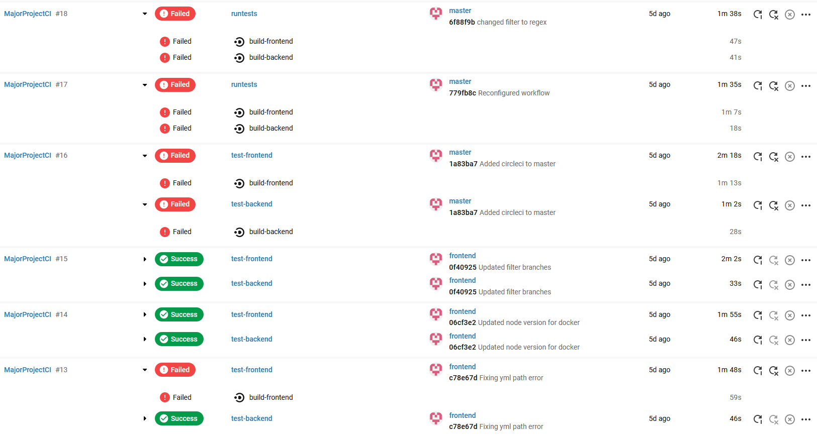

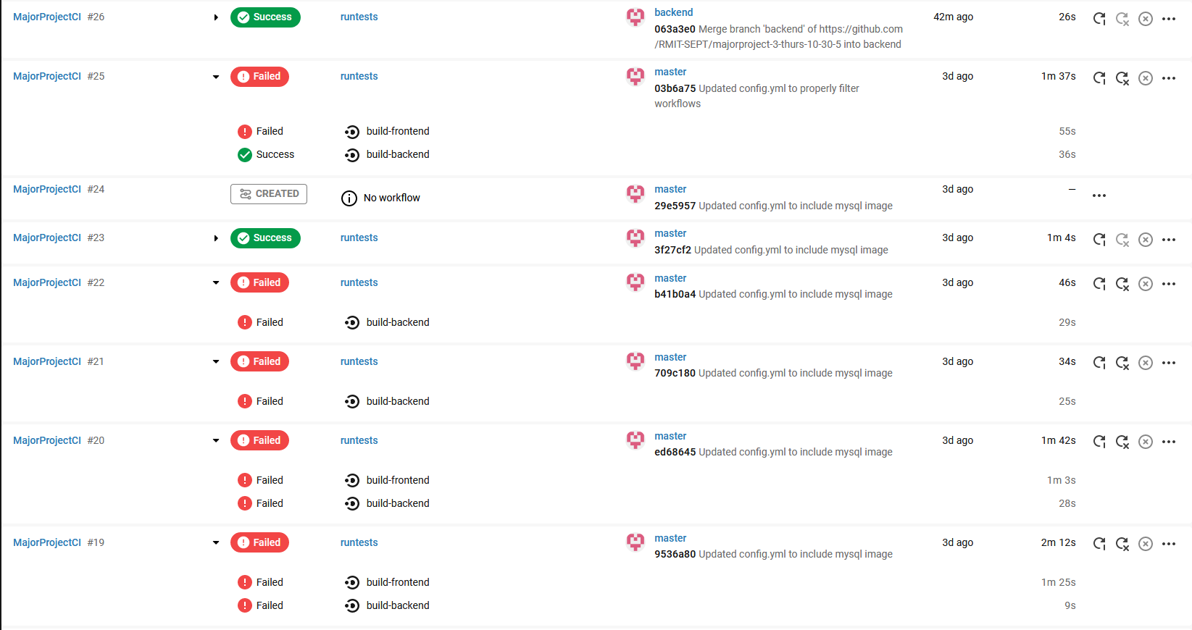

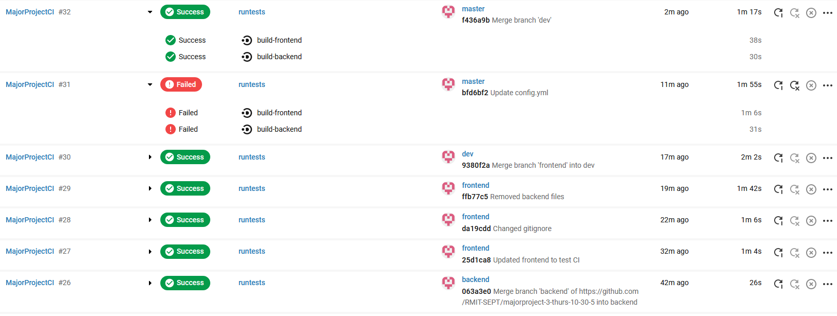

# Functionality Summary

* Since our last sprint, we have implemented our registration functionality, both sign-up and login, complete with form validation, (Invalid input, empty input, etc). This extends to fully working Front End/Back end communication.
* Additionally, the Service booking page has been created and is fully functional, complete with visual styling.
* The about us page and contact page have been created and been given front end visual styling. As well as updated visuals on the Home Page.
* CircleCI has been integrated, as demonstrated by our various tests listed above.
* Repos have been established for Appointments, Availability, Bookings and Workers.

# Screenshot of AWS deployment

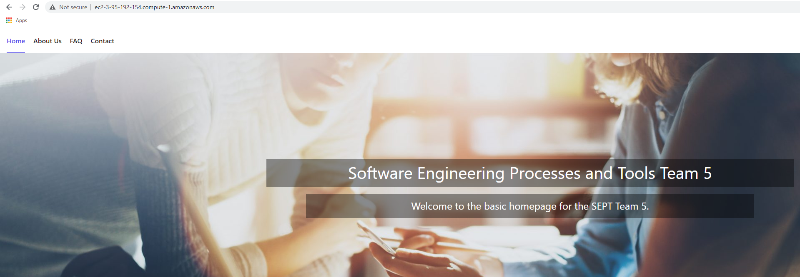

# Burndown Chart

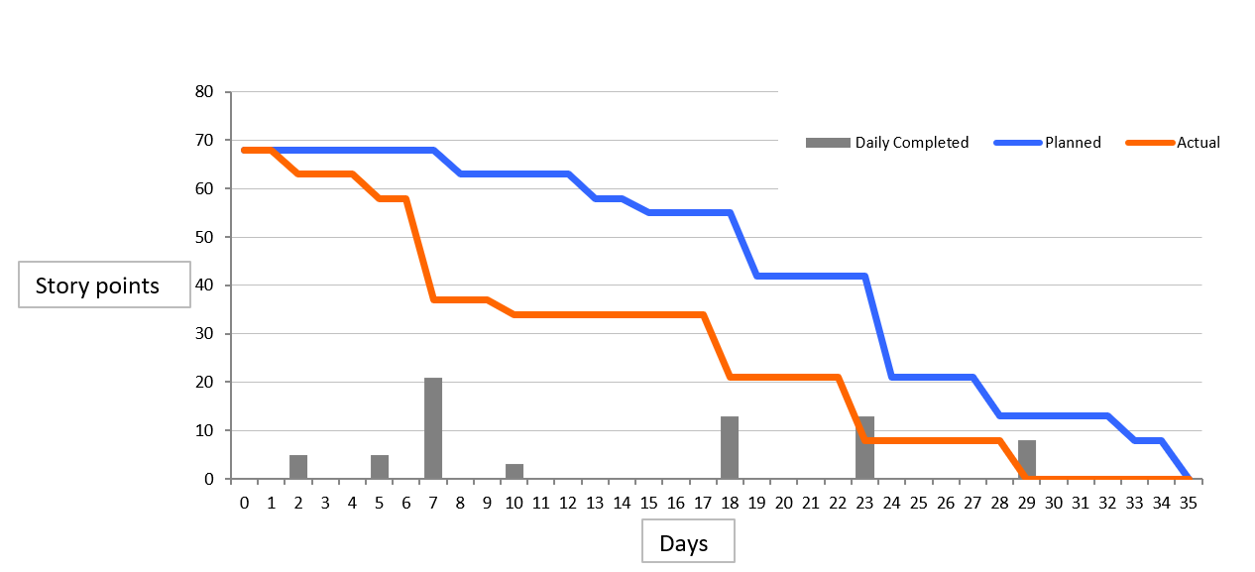

# New Test File locations

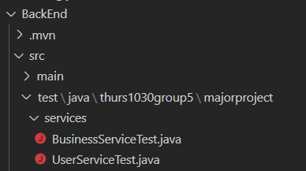

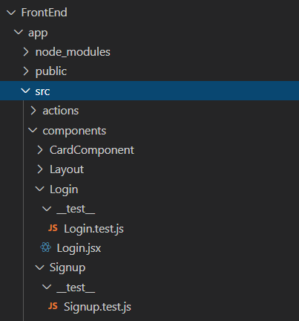

# Sprint Retro notes

Team: Thurs-10:30-5

Sprint: 1

Date: 17/09/2020

Attended:

Scrum Master: Athanasios Papaharisis

Product Owner: Marco Nadalin

Development team: Raymond Caucci

Michael Weston

Marcus Matic

## 1. Things That Went Well

*The team has been working together fantastically, everyone has been incredibly supportive of each other and been able to work incredibly efficiently and effectively, with great communication, as well as the integration of a Git bot into our communication server that can keep everyone constantly updated with progress.*

## 2. Things That Could Have Gone Better

*Some minor issues regarding Github occurred but were remedied very quickly. Additionally, there were two meeting minutes in the Gdrive that were unfortunately not added to the meeting minutes which resulted in a lower grade than was possible.*

## 3. Things That Surprised Us

*CircleCI issues regarding funding was a sudden shift in our planned schedule due to sudden shift in our timings.*

## 4. Lessons Learned

*While maintaining a schedule is integral to efficient workflow, some flexibility is required to be able to quickly adapt to sudden changes. We have all been able to*

## 5. Final Thoughts

*Throughout the project so far, the progress has been incredible, and the communication has been constant. Looking forward, we all believe that we will be able to continue this level of progress and are, again, confident that the coming tasks will be completed to a high level of quality*

# Sprint Planning notes

Team: Thurs-10:30-5

Sprint: 2

Date: 17/09/2020

Attended:

Scrum Master: Athanasios Papaharisis

Product Owner: Marco Nadalin

Development team: Raymond Caucci

Michael Weston

Marcus Matic

1. Goal

*Through this sprint, we seek to further the functional requirements for the project, implementing the registration and login functionality, as well as creating and filling the functionality of the services page.*

1. Duration of the sprint

*2 weeks*

1. What is the team’s vision for this sprint?

*The currently envisioned features to be placed in the sprint backlog are the various features regarding the services page. Additionally, the customer registration functionality. More specifically:*

* *3.1: Create customer sign-up front-end UI*
* *3.2: Create customer sign-up back-end functionality*
* *4.1: Creation of Service page*
* *4.2: Customers can view available services*
* *4.3: Customers can view the worker providing services*

*By the end of the sprint, we hope to have these tasks completed and maintain the current level of production moving into the next sprint to ensure entire completion of the project according to our current momentum through story points*

1. Estimation in story points

*Using the Fibonacci sequence method of story points, as a team, we settled on*

* ***3.1: Create customer sign-up front-end UI: 5***
* ***3.2: Create customer sign-up back-end functionality: 5***
* ***4.1: Creation of Service page: 8***
* ***4.2: Customers can view available services: 13***
* ***4.3: Customers can view the worker providing services: 8***

# Meeting Minutes

# Meeting No: 4 Week 5

|  |  |
| --- | --- |
| **Date:** | 27/08/2020 |
| **Venue:** | Microsoft Teams |
| **Attendees:** | Athanasios Papaharisis, Marco Nadalin, Raymond Caucci, Michael Weston |
| **Apologies:** | Marcus Matic |
| **Absences:** | N/A |
| **Scrum Master:** | Nas |
| **Minutes:** | 10 |

|  |  |  |  |  |
| --- | --- | --- | --- | --- |
| **No.** | **Issue** | **Discussion** | **Action** | **Member** |
| **1** | Trello planning | Required increase in Trello uploads, including “user stories” and the formatting of sprint cards | Athanasios will upload the user stories, and reformat the sprint cards/categories in line with Sachin’s suggestions | Athanasios |
| **2** | Scrum Meeting | Had a stand-up scrum meeting to discuss the previous week’s actions and the upcoming tasks required leading up to the break | Front end and back end team will work to getting the two branches merged and functional over the break | All members |
| **3** | Sprint 1 Update | Met with Sachin and demonstrated via Trello board what our progress was, noting suggestions and improvements | Whole team will begin preparing for next sprint submission | All members |

# Meeting No: 5 Week 6

|  |  |
| --- | --- |
| **Date:** | 01/09/2020 |
| **Venue:** | Discord |
| **Attendees:** | Athanasios Papaharisis, Marco Nadalin, Raymond Caucci, Michael Weston, Marcus Matic |
| **Apologies:** |  |
| **Absences:** | N/A |
| **Scrum Master:** | Nas |
| **Minutes:** | Nas |

|  |  |  |  |  |
| --- | --- | --- | --- | --- |
| **No.** | **Issue** | **Discussion** | **Action** | **Member** |
| **1** | N/A | Group did individual stand-up to show off current progress, issues and plans | N/a | All |
| **2** | Spring login issue | Login functionality is suffering from issues from unique method of login integration and json implementation. | Front end and back end team will work to getting the two branches merged and functional over the break | Michael |
| **3** | Installation Tutorial | Nas’ computer was unable to run node.js properly | Team troubleshooted to fix issues | All members |
| **4** | Front End minor work | Sign in page requires updated frontend graphical design | Nas will do some small styling and graphics on the signin page | Nas (Athanasios) |

# Meeting No: 6 Week 7

|  |  |
| --- | --- |
| **Date:** | 09/09/2020 |
| **Venue:** | Discord |
| **Attendees:** | Athanasios Papaharisis, Marco Nadalin, Raymond Caucci, Michael Weston, Marcus Matic |
| **Apologies:** |  |
| **Absences:** | N/A |
| **Scrum Master:** | Nas |
| **Minutes:** | Nas |

|  |  |  |  |  |
| --- | --- | --- | --- | --- |
| **No.** | **Issue** | **Discussion** | **Action** | **Member** |
| **1** | N/A | Group did individual stand-up to show off current progress, issues and plans | N/a | All |
| **2** | Front End Registration presentation | Presented front end for registration | Will implement from person computer to git | Nas |
| **3** | Dashboard front-end | Presented updated front end as part of standup | N/A | Raymond/Marco |
| **4** | Submission Requirements | Login and registration functionality will be focused on for submission | Login and registration functionality will be focused on for submission |  |
| **5** | Meeting plan | Discussed plan for friday meeting with Sachin and relevant tasks for presentation |  | All |

# Meeting No: 7 Week 8

|  |  |
| --- | --- |
| **Date:** | 16/09/2020 |
| **Venue:** | Discord |
| **Attendees:** | Athanasios Papaharisis, Marco Nadalin, Raymond Caucci, Marcus Matic, Michael Weston |
| **Apologies:** | N/A |
| **Absences:** | N/A |
| **Scrum Master:** | Nas |
| **Minutes:** | Nas |

|  |  |  |  |  |
| --- | --- | --- | --- | --- |
| **No.** | **Issue** | **Discussion** | **Action** | **Member** |
| **1** | Merge conflicts | Discussion regarding current merge conflicts and the Dev/Master branch | Merge will be set at a future date, then rebranched | Marco |
| **2** | Individual standup | All members discussed current progress and plans for upcoming sprint presentation | Members will continue working on their assigned tasks | All Members |
| **3** | Change of database logic | Change method of posting requests regarding Businesses in the database/backend | Changes will need to be made on the frontend regarding business access | All Members |
| **4** | Follow up regarding Sprint Retro/Review and Sprint 2 planning | Meeting required to fill out sprint retro, review and planning forms | Meeting has been set and will be filled out by Athanasios | Athanasios |
| **5** | Preparation for Milestone 2 submission | Milestone 2 requires work over next few days to be in a submittable state by submission date | Athanasios will compile and fill documents before next meeting | Athanasios |

# Meeting No: 8 Week 8

|  |  |
| --- | --- |
| **Date:** | 17/09/2020 |
| **Venue:** | Microsoft Teams |
| **Attendees:** | Athanasios Papaharisis, Marco Nadalin, Raymond Caucci, Marcus Matic, Michael Weston, Sachin Pathiyan Cherumanal |
| **Apologies:** | N/A |
| **Absences:** | N/A |
| **Scrum Master:** | Nas |
| **Minutes:** | Nas |

|  |  |  |  |  |
| --- | --- | --- | --- | --- |
| **No.** | **Issue** | **Discussion** | **Action** | **Member** |
| **1** | Junit Tests required for presentation |  | Junit tests presented with no issues | All |
| **2** | Questions about Milestone submission | Questions were asked regarding Circle CI and minutes submission. | Screenshots of CircleCi compile to be set and put inside milestone | Nas |
| **3** | Began Sprint 3 planning document | Sprint 3 planning document was discussed with some tasks being completed | Sprint 3 Milestone document has been mostly completed, with Sprint 2 Retro and Story point allocation to be completed at a later meeting | All |
| **4** |  |  |  |  |
| **5** |  |  |  |  |

# Meeting No: 9 Week 9

|  |  |
| --- | --- |
| **Date:** | 22/09/2020 |
| **Venue:** | Discord |
| **Attendees:** | Athanasios Papaharisis, Marco Nadalin, Raymond Caucci, Marcus Matic, Michael Weston |
| **Apologies:** | N/A |
| **Absences:** | N/A |
| **Scrum Master:** | Nas |
| **Minutes:** | Nas |

|  |  |  |  |  |
| --- | --- | --- | --- | --- |
| **No.** | **Issue** | **Discussion** | **Action** | **Member** |
| **1** | Sprint 2 Milestone Submission | Discussed submission of milestone and went over as group alongside Sachins emailed improvements | Improvements were added and group has given go ahead for submission | All |
| **2** | Discussion regarding moving onto milestone 3 | Scrum stand-up with all members to determine current progress | Discussion went forward appropriately with no surprising details | All |

***User Stories/Acceptance Tests/ Product Backlog***

Please see Trello, all available there